**Game flow diagram**

The game at level six has the flow shown in figure (….). The flow chart is constructed using the following. Process, decision, event and check (audit).

* The rectangle shows a process
* The smooth angle rectangles show event
* The diamond shows decision
* The small black diamond show check(audit)



**Figure (….) Game Flow Diagram**

**Architectural Design**

**Graphical Representation**

The architectural design for level six has seven modules. Environment, Sound, Enemy, Weapons, Map, Player (main character), and Fellow Warriors. The interaction between these modules is shown in the figure (…..)



**Figure (…..) Module Relation Diagram**

**Description of Architecture Views**

The interaction between the different modules is clearly shown above using the Relations diagram.

Below is a slightly detailed description of this modules.

1. Weapons

In this stage of the game (level 6) the fellow warriors and the player will use the following weapons for attack:

1. Spear
2. Shield

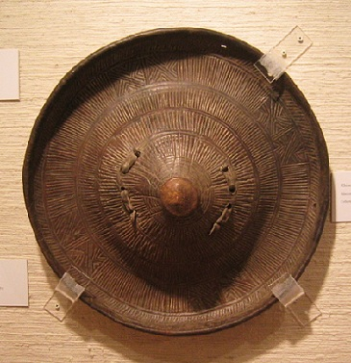

Figure (….) a sample picture of shield used by the Player

1. Shotel (A **shotel** is a curved sword originating in Abyssinia. The curve on the shotel's blade has an almost semi-circular shape. The blade is flat and double-edged with a diamond cross-section. The blade is about 40 inches (1,000 mm) in total length and the hilt is a simple wooden piece with no guard. The shotel was carried in a close fitting leather scabbard )

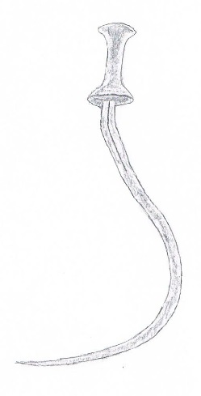

Figure (….) sketch of Shotel

1. Sound

The battle at this stage is fought between the Oromo cavalry and the player on one side and the Italian forces led by General Vittorio Dabormida. Due to the constraints discussed on the previous SRS document the player will not be on horseback. But in an effort not to overlook and diminish the Oromo cavalry’s role in the battle the following sound tracks will be added:

1. Horses charging
2. Horses jumping
3. Horses falling

In addition the following sounds are included

1. Sounds created by the use of the weapons
2. Sounds that reflect human conditions( absorbing pain, giving commands,running)
3. Enemy

The enemy of the player at level six are grouped in to two. The first enemy to be faced is a group of thirty soldiers in the Italian army. If the player is able to defeat this group of enemy he will advance to face General Vittorio Dabormida.

1. Environment

At the Start of the game the player and his fellow warriors will face their rival enemies (the Italians under command of General Vittorio Dabormida in a plane site view. But as the game starts to progress and the player has an upper hand the Italians will retreat in to a narrow valley where they will be cornered and are at disadvantage. Therefore the battle background is comprised of a plain field and a narrow valley.

The scenery of the environment will be a barren land with very little vegetation.

1. Map

The Map for this stage will show a plain field where the game starts and the place where the player advances if he is able to wound Gen. Vittorio Dabormida (the narrow Valley).

1. Player (main character)

The player will have the following weapons (spear, shotel with leather scabbard and shield), the player will be clothed in a fashion similar to the one shown in the picture below.

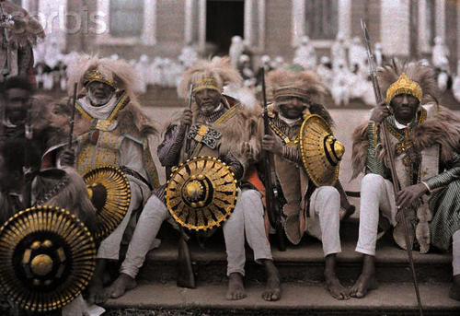

Figure (….) sample picture for clothing style of the player (main character)

1. Fellow warriors

For this level (level 6) the player is a ground soldier and fights on foot and its fellow warriors also are in foot. To show the overwhelming number of the Ethiopians over the Italians the fellow warriors will be greater in number, 40 soldiers. The numbers here doesn’t reflect the true ratio of fighters in both side of the story and are fictional. The fellow warriors will cloth in a similar manner as for the player (main character) described above. But for identification purpose the colouring of the clothes will be made different. Black clothes for the fellow warriors and white for the fictional main character (player).

**Interaction between Views**

This level contains two main game scenes, one is the Graphical User Interfaces (GUI) scene and another one is the game scene. The player could play on or off the background music, view the information of the controller and start or end this game on the GUI scene. The skybox, rigid body, players, enemies, weapons, HealthPoint Bars and Terrain will be applied to the game scene.

The game scene for this specific level contains different components in which all of them will be designed in order to narrate the historic war between the Ethiopian Oromo Cavalry and the Italian’s Army lead by Dabromida at the battle of Adwa. These are:

1. **Terrain**

The terrain of this level will be developed with flora from grass, shrub and with low density of forest tree.Other game objects containing enemy objects and cube objects will be arranged on the terrain also. They constitute a completed game level together. Every game object obtains its own function in the game. This terrain will be designed to look like a narrow valley where the Oromo cavalry under Ras Mikael slaughtered Dabromida’s brigade.

1. **Skybox**

The main function of sky boxes is filling colourful to the sky space in the game. In this level the basic blue sky and white clouds will be filled.

1. **Player**

The player is the main character in the game which will be controlled by the user in this level the player will find himself in front of 30 Dabromida’s soldiers inside a narrow valley.

1. **Enemies**

For this level there will be 30 enemy soldiers and one enemy leader who is Dabromida. These players will be activated in random fashion when the player is in a certain range from them. Then they will come to the player and attack him.

1. **Weapons**

The main weapons which will be used for this level are:

* Sword
* Spear
* Shot gun

The player will have a permission to use any of these weapons but the enemies will

have the permission to use only shot gun.

**4. Detail Game Design**

This level is single player battle game which the player had to search the enemies on the terrain map and kill the enemies by using the available weapon.

This level will have two check points. The player will reach the first check point after killing 30 Italian soldiers and the player will reach the second check point when he or she spot at Dabromida and injure him. If the player will be slain before reaching the first check point, then the game will be over. After passing the first check point, if the player failed to wound dabromida, the player gets set back to the previous checkpoint that is achieved after killing the 30 soldiers.

**4.1Health Points**

Health Points (HPs) will be used to judge whether the player or enemies died. The player could restore HPs according to touching the Heal Box or finishing a mission. There will be two Heal-Points bars to be indicated on the game window. One will be placed at top-left of the game window and will be used to display health points of the enemies. The other one will be placed at the bottom-left of the game window and will be used to display the health points of the player.

**4.2 Heal Boxes**

Another important feature in this level is ‘Heal-boxes’. The heal-boxes are the game objects which will be distributed on the terrain. Their function is to increase the health points of the player when the player finds and touches them. To implement the function, three steps must be considered. Firstly the player must collide with the heal-boxes and secondly the heal-boxes increase the heal-points of the player. Finally the heal-boxes must be destroyed.

Void restoreHealthPoints()

{

1. Collide with the heal box
2. Increase the health points of the player
3. Destroy heal box

}

**4.3 Damage Calculation System**

Health Points are finite value used to determine how much damage a character can withstand.When a character is attacked, the total damage dealt (which is also represented by a point value) is subtracted from its current HPs.The damage system is used to control the HPs of the player and enemies.

For this level initially both the player and the enemies will have 35 HPs. The damage which the player got from the enemy is 1 HP every hit. If the HP of the player is equal or less than 0 before achieving the first check point, then the game will be over, else if the HP of the player is equal or less than 0 after achieving the first check point,then the player gets set back to the previous checkpoint that is achieved after killing the 30 soldiers.

Void damageCalculation()

{

If (attacked)

{

HP=HP-1;

}

If(HP<=0)

{

Player status=died;

gameOver();

}

}

**4.4 The 3D space and Camera Orientation**

The camera is a critical component because it displays all actions of the game objects to the player on the game scene. As a result the lens through the game scene is perceived. Comprehending how the camera moves and how to adjust what it acquires is essential knowledge for this level**.**

**4.5 The Interaction between 30 enemy soldiers**

The location 30 enemy soldiers and their leader Dabromida will be governed by clearly defined rules.

Rule1. There will be pre-defined distance gap between these 30 enemy soldiers.

Rule2. They will be activated when the player is in a certain range from them.

Rule3. Maximum of 3 closer enemy soldiers can attack the player at the same time.

Rule4. They will become died if they got one hit from the player only their leader Dabromida can withstand up to five hits until he become heavily wounded.

**4.6Basic Enemy Actions**

**4.6.1 Running:**

The enemies will be designed to run in the direction of the player. This will be achieved by calculating the current position of the player and give command to a random enemy soldier to run in the direction of the current player position.

Void enemyRun()

{

1. Calculate the player current position

2. Move toward the player current position

3. Continuously increase the player velocity in that direction}

**4.6.2 Walking:**

This will give each enemy soldier an ability to walk around the environment and search for the player.

Void enemyWalk()

{

1. Move in a random direction with constant velocity
2. Continuously change its direction to left, right, north and south in random fashion until get closer to the player

}

**4.6.3 Standing Still:**

This action will allow the enemy soldiers to stand still at a given fixed point and attack the player

Void enemyStandsStill()

{

1. Maintain its position at a fixed point

}

**4.6.4 Shooting:**

This action is the attacking mechanisms of the enemy soldiers.

Void enemyShoot()

{

If(enemy_closer_enough_to_the _player)

{

1. Aim at the player
2. Shoot }

}

**4.7Basic Player Actions**

**4.7.1 Running:**

Void playerRun()

{

If (Move_Key_Pressed&&Run_Key_pressed)

{

1. Move forward in the current direction

2. Continuously increase the player velocity in the current direction

}

}

**4.7.2 Walking:**

Void playerWalk()

{

If(Move_Key_Pressed)

{

If (Move_Key_pressed ==Move_Key_Left)

{

1. Change the player direction to left

2. Move the player with constant velocity to the left

}

Else If (Move_Key_pressed ==Move_Key_Right)

{

1. Change the player direction to Right

2. Move the player with constant velocity to the right

}

Else If (Move_Key_pressed ==Move_Key_UP)

{

1. Change the player direction to north

2. Move the player with constant velocity to the north

}

Else {

1. Change the player direction to south

2. Move the player with constant velocity to the south

}

}

}

**4.7.3 Standing still:**

Void playerStandStill()

{

If(!Move_key_pressed)

{

1. Maintain current position

}

}

**4.7.4 Jumping:**

Void playerJump()

{

If(Jump_Key_Pressed)

{

1. Change the player position in the z direction
2. Continuously increase the player velocity in the z-direction

}

}

**4.7.5 Shooting**

Void playerShoot()

{

If(shoot_Key_Pressed)

{

If(Selected_Weapon==­­sword)

{

1. Aim at the enemy

2.playerSwingSword();

}

Else if (Selected_Weapon==spear)

{

1. Aim at the enemy

2. playerThroughSpear();

}

Else if (Selected_Weapon==shotGun)

{

1. Aim at the enemy
2. playerShotGun();

}}}

**4.7.6 Swing Sword:**

Void playerSwingSword()

{

Execute swing sword script

}

**4.7.7 through Spear:**

Void playeThroughSpear()

{

Execute throwing spear script

}

**4.7.7 Shoot Gun:**

Void playerShootGun()

{

Execute shoot gun script

}

**4.8 Sounds**

This level will be designed with different type of sounds which should be heard while playing the game.­

Void backGroundMusic () {

Starts the kind of sound that will be playing in the background at the start of the game;

}

Void soundWeapon() {

If (shoot_key_pressed&&typeOfWeapon == spear)

Play sound of spear being thrown;

Else If(shoot_key_pressed&&typeOFWeapon==sword)

Play sound of sword being swing;

Else If(shoot_key_pressed&&typeOfWeapon==shot gun)

Play sound of shoot gun;

Else

Do nothing;

}

Void soundOfHit () {

If (got hit)

Play sound hit;

Else

Do nothing;

}

Void soundOfDying () {

If (HPs<=0)

Play sound of dying;

Else

Do nothing;

}